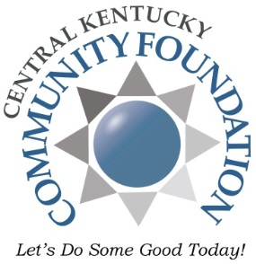

Central Kentucky Community Foundation presents

*Get Ready! Camp 2018*

A free summer learning program specially designed for

children birth – 5 years old and their families

**PLAYING**

**TO**

**LEARN**

*Children learn through play and hands on activities

*Parents learn how their child grows and develops

*Learn how to include learning experiences in your

child’s everyday life

**June 11th – June 29th**

**weekdays**

**Anytime from 9 – 11 am**

**Panther Academy in Elizabethtown**

**North Park Elementary in Radcliff**

**Anytime from 11:30 am – 1:30 pm**

**Heartland Elementary in Elizabethtown**

**North Park Elementary in Radcliff**

It’s **FREE**

and open to everyone!

everyone!!



No registration required!!

Join us for lunch/snack FREE to all children!

C:\Documents and Settings\jmonday\Local Settings\Temporary Internet Files\Content.IE5\QJEWOMV1\MC900438229[1].wmf

*For more information call 270-737-8393*

*www.ckcf4people.org/get-ready*